WEEK – 3

Exercise 4: Creating and Configuring a Maven Project

Nipuna.A

Superset id: 6432842

**Scenario:**

You need to set up a new Maven project for the library management application and add Spring dependencies.

**Steps:**

1. **Create a New Maven Project:**
   * Create a new Maven project named **LibraryManagement**.
2. **Add Spring Dependencies in pom.xml:**
   * Include dependencies for Spring Context, Spring AOP, and Spring WebMVC.
3. **Configure Maven Plugins:**
   * Configure the Maven Compiler Plugin for Java version 1.8 in the pom.xml file.

Solution:

1)BookRepository.java

package com.library.repository;

public class BookRepository {

    public String getBookDetails() {

        return "Book details from repository.";

    }

}

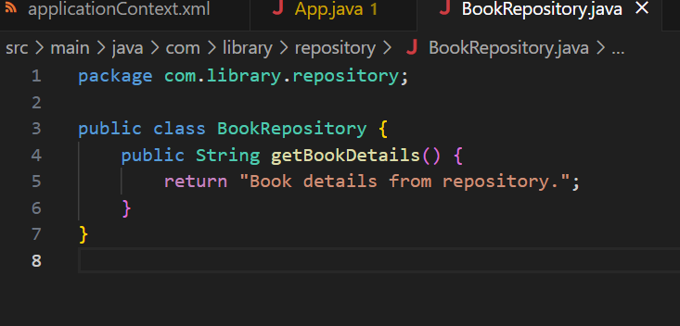

2)BookService.java

package com.library.service;

public class BookService {

    public void addBook(String title) {

        System.out.println("Adding book: " + title);

    }

    public void showDetails() {

        System.out.println("Details: Book details from repository.");

    }

}

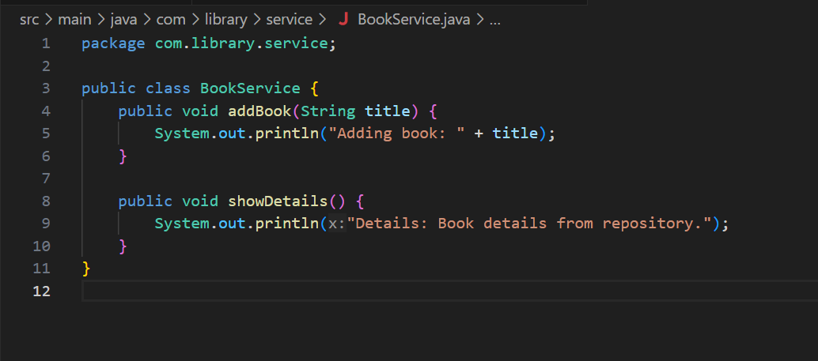

3)App.java

package com.library;

import com.library.service.BookService;

import org.springframework.context.ApplicationContext;

import org.springframework.context.support.ClassPathXmlApplicationContext;

public class App {

    public static void main(String[] args) {

        ApplicationContext context = new ClassPathXmlApplicationContext("applicationContext.xml");

        BookService bookService = context.getBean("bookService", BookService.class);

        bookService.addBook("Spring Framework Basics");

        bookService.showDetails();

    }

}

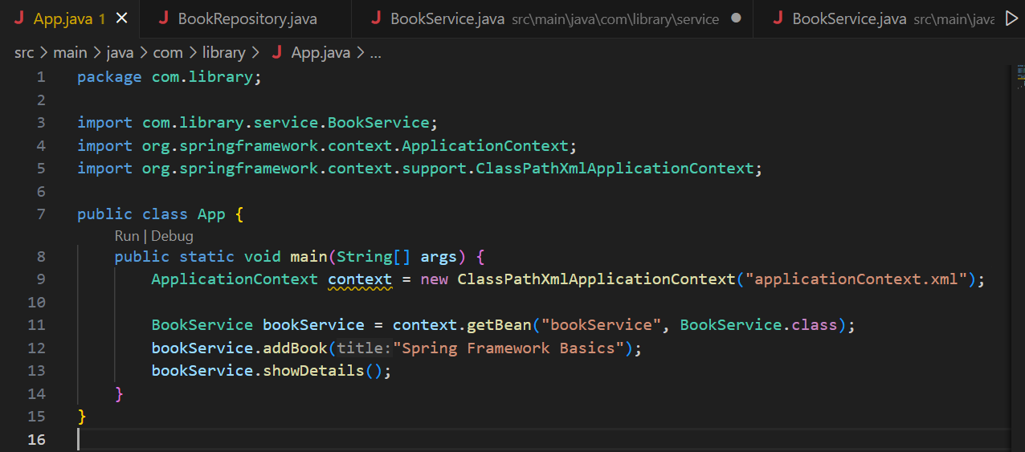

4)ApplicationContext.xml

<?xml version="1.0" encoding="UTF-8"?>

<beans xmlns="http://www.springframework.org/schema/beans"

       xmlns:xsi="http://www.w3.org/2001/XMLSchema-instance"

       xsi:schemaLocation="

           http://www.springframework.org/schema/beans

           http://www.springframework.org/schema/beans/spring-beans.xsd">

    <bean id="bookService" class="com.library.service.BookService"/>

</beans>

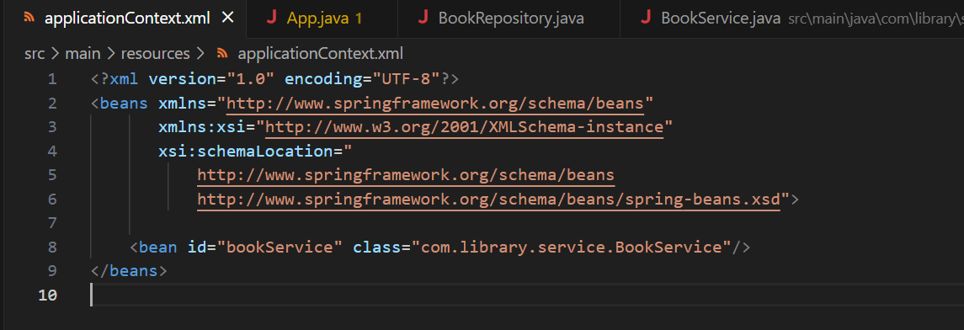

6)Pom.xml

<?xml version="1.0" encoding="UTF-8"?>

<project xmlns="http://maven.apache.org/POM/4.0.0"

         xmlns:xsi="http://www.w3.org/2001/XMLSchema-instance"

         xsi:schemaLocation="http://maven.apache.org/POM/4.0.0

                             http://maven.apache.org/xsd/maven-4.0.0.xsd">

    <modelVersion>4.0.0</modelVersion>

    <groupId>com.library</groupId>

    <artifactId>LibraryManagement</artifactId>

    <version>1.0-SNAPSHOT</version>

    <properties>

        <maven.compiler.source>1.8</maven.compiler.source>

        <maven.compiler.target>1.8</maven.compiler.target>

    </properties>

    <dependencies>

        <!-- Spring Context -->

        <dependency>

            <groupId>org.springframework</groupId>

            <artifactId>spring-context</artifactId>

            <version>5.3.36</version>

        </dependency>

        <!-- Spring AOP -->

        <dependency>

            <groupId>org.springframework</groupId>

            <artifactId>spring-aop</artifactId>

            <version>5.3.36</version>

        </dependency>

        <!-- Spring WebMVC -->

        <dependency>

            <groupId>org.springframework</groupId>

            <artifactId>spring-webmvc</artifactId>

            <version>5.3.36</version>

        </dependency>

    </dependencies>

    <build>

        <plugins>

            <!-- Maven Compiler Plugin -->

            <plugin>

                <groupId>org.apache.maven.plugins</groupId>

                <artifactId>maven-compiler-plugin</artifactId>

                <version>3.8.1</version>

                <configuration>

                    <source>1.8</source>

                    <target>1.8</target>

                </configuration>

            </plugin>

            <!-- Maven Exec Plugin -->

            <plugin>

                <groupId>org.codehaus.mojo</groupId>

                <artifactId>exec-maven-plugin</artifactId>

                <version>3.1.0</version>

                <configuration>

                    <mainClass>com.library.App</mainClass>

                </configuration>

            </plugin>

        </plugins>

    </build>

</project>

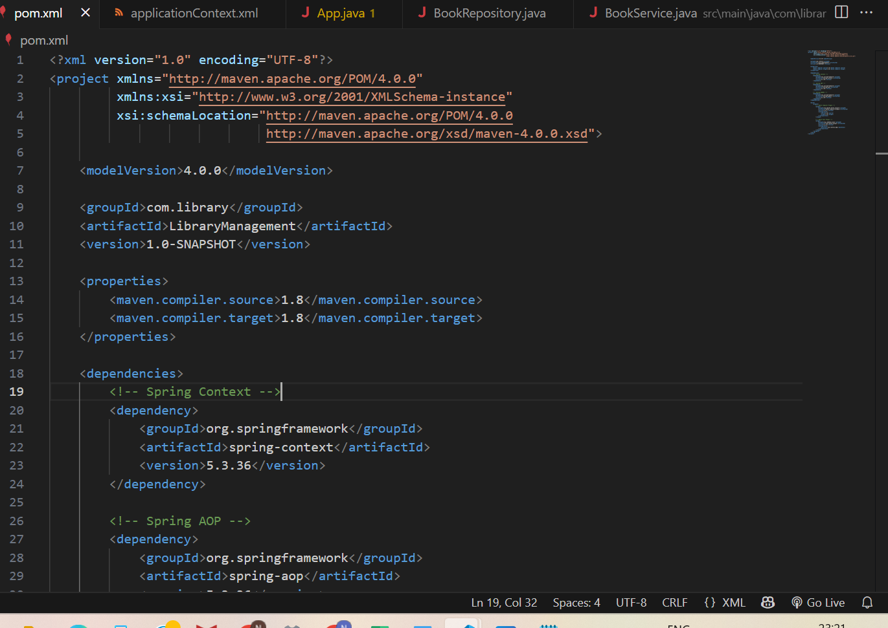

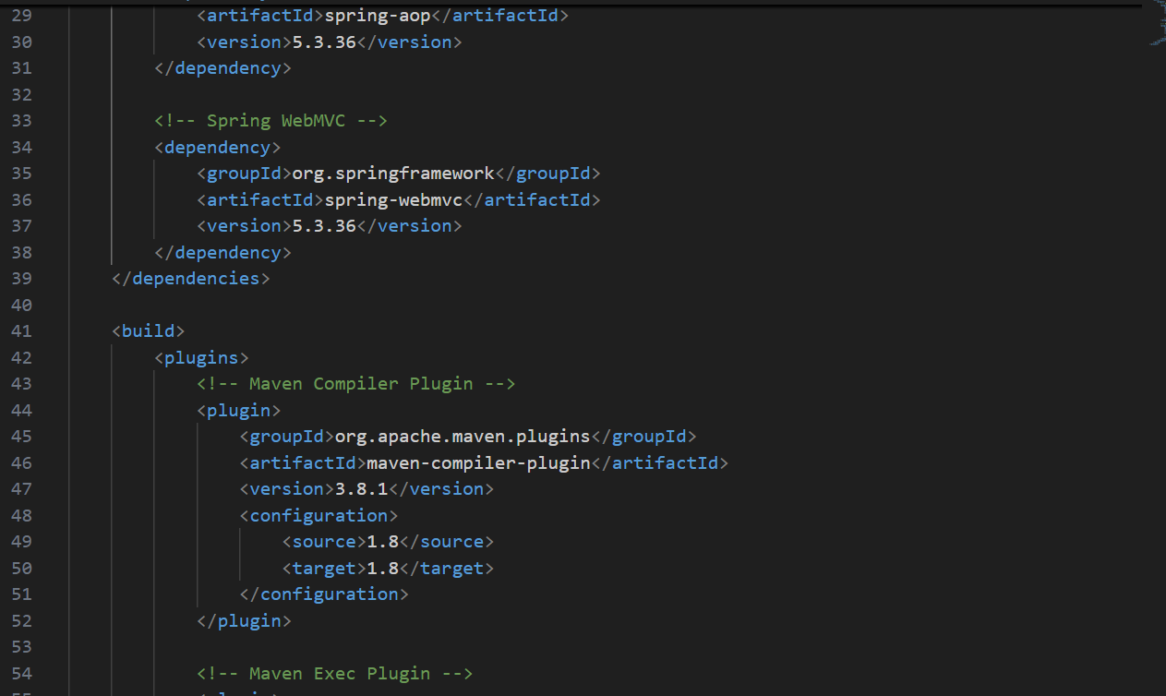

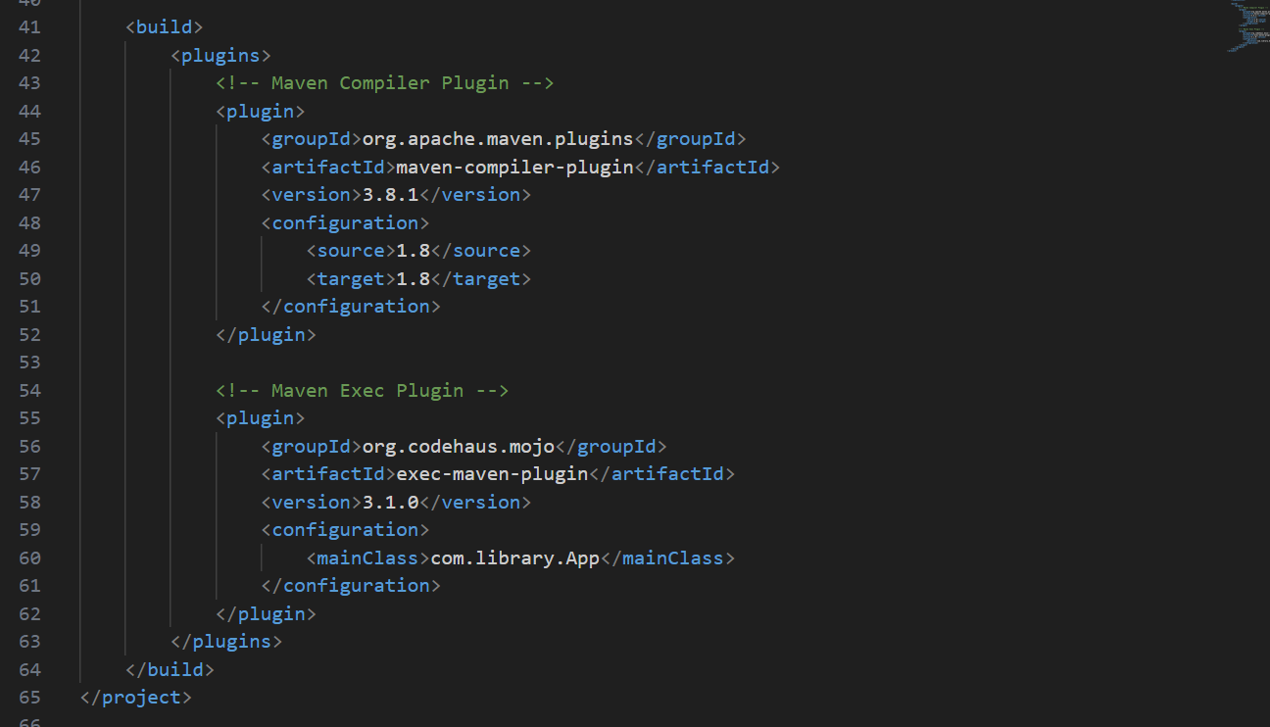

Output:

